Games Development Group Design Document
Midterm Assessment
Game Title: Last Light
Team Members:
- Juan Patxot
- Dianshi Yang
- Agata Gawkowska
- Ionut-Alexandru Bacanu

Contents

Elevator Pitch 2
Summary 2
Unique Selling Points (USPs) 4
The Team 4
Evidence of Prototyping 5
Prototype 1: Core Gameplay Loop 5
Prototype 2: Power Decay and Time Pressure 6
Prototype 3: Light and Enemy Relationship 7
Key Mechanics 8
Player Movement 8
Interaction 8
Power Decay System 8
Enemy Behavior 8
Core Gameplay Loop 8
Characters and Settings 9
Player Character 9
Enemies 9
Setting 9
Narrative Context 9
Beginning the Game 9
First 2–5 Minutes 9
Style 10
Audio 10
SWOT Analysis 10
Strengths 10
Weaknesses 10
Opportunities 11
Threats 11
Production Schedule (12 Weeks) 12
List of All Assets 12
Visual Assets 12
Audio Assets 13
Systems to Program 13
Conclusion 13

Elevator Pitch
Last Light is a short, single-player survival game set during a citywide blackout, where the player must maintain power across a failing city block while avoiding shadow enemies that emerge from darkness. Using light as both a visual and mechanical system, the game challenges the player to prioritize movement, manage time pressure, and survive until morning.

Summary
Last Light is a 2D, top-down survival game designed to be played in a single session lasting between five and ten minutes. The game is set in a small urban environment experiencing a prolonged power outage. The player assumes the role of a city maintenance worker whose task is to keep the city block operational by restoring power to buildings that gradually lose electricity over time.
As buildings fall into darkness, hostile shadow entities appear, increasing the level of danger within the environment. The player must continually assess the state of the city, decide which buildings require immediate attention, and move efficiently to prevent being overwhelmed. The game places strong emphasis on visual feedback, environmental storytelling, and emergent tension rather than complex controls or narrative exposition. The experience is intended to be immediately accessible, while still offering meaningful decision-making and challenge.

Unique Selling Points (USPs)
One of the primary unique selling points of Last Light is the use of light as a central gameplay system rather than a purely aesthetic element. Light directly influences enemy behavior, player safety, and the overall state of the game world. This ensures strong thematic coherence between mechanics and setting.
The game also distinguishes itself through its minimalist design philosophy. Rather than relying on numerous mechanics or systems, Last Light focuses on a small number of interconnected mechanics that are repeatedly reinforced through gameplay. This allows the player to quickly understand the rules of the game while still being required to make strategic decisions under pressure.
Additionally, the city environment itself functions as a form of visual storytelling. The gradual loss or restoration of light across the city block communicates progress, failure, and urgency without the need for dialogue or written narrative. This aligns with the project’s goal of being easy to pick up and play.

The Team
The development team consists of four members. While responsibilities may overlap as development progresses, initial roles have been assigned to ensure clear accountability and effective time management.
Juan Patxot – Project Lead and Gameplay Programmer
Responsible for coordinating development tasks, managing version control, and implementing core gameplay mechanics such as player movement, interaction, and overall system integration within Unity.
Dianshi Yang – Systems and AI Programmer
Responsible for the design and implementation of the power decay system, enemy behavior, difficulty progression, and overall game state management.
Agata Gawkowska – Level Design and User Interface
Responsible for designing the city block layout, building placement, camera framing, and user interface elements, ensuring gameplay readability and flow.
Ionut-Alexandru Bacanu – Audio, Visual Assets, and Polish
Responsible for sourcing and implementing visual and audio assets, configuring lighting effects, managing animation assets, and contributing to final presentation polish.

Evidence of Prototyping
Prototyping was used as a core design tool to validate the mechanics of Last Light before committing to full production. In accordance with recommended prototyping practices, all prototypes were intentionally low-fidelity, inexpensive, and easily modifiable, with a focus on testing gameplay systems rather than visual presentation or narrative elements.

Prototype 1: Core Gameplay Loop
The first prototype focused on identifying and validating the core gameplay loop. This prototype was created using simple flow diagrams and paper sketches to represent the player, buildings, power decay, and enemy spawn conditions. The objective was to clarify what the player does repeatedly, what decisions they are required to make, and how the game state changes over time.
Group discussion around this prototype revealed that a compact play space was essential to maintaining tension and preventing downtime. It also highlighted the importance of making the relationship between light, safety, and danger immediately visible. As a result, the design was refined to use a single city block rather than multiple levels, with escalating pressure over time. (See Figure 1).
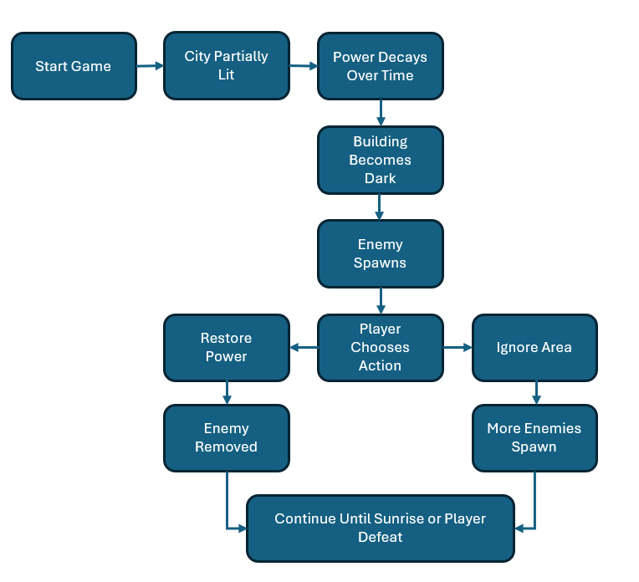
Figure 1: Core Gameplay Loop

Prototype 2: Power Decay and Time Pressure
The second prototype focused exclusively on the power decay system. Using simplified representations of buildings and timers, the group explored how quickly power should drain and how many buildings should be active simultaneously. This prototype intentionally excluded enemies in order to evaluate whether time-based pressure alone could create engagement.
Testing and discussion demonstrated that even without enemies, the gradual loss of power created meaningful urgency and forced prioritization. This confirmed that power decay should be the foundational mechanic of the game. As a result, difficulty progression was designed around increasing decay rates rather than introducing additional mechanics. (See Figure 2)
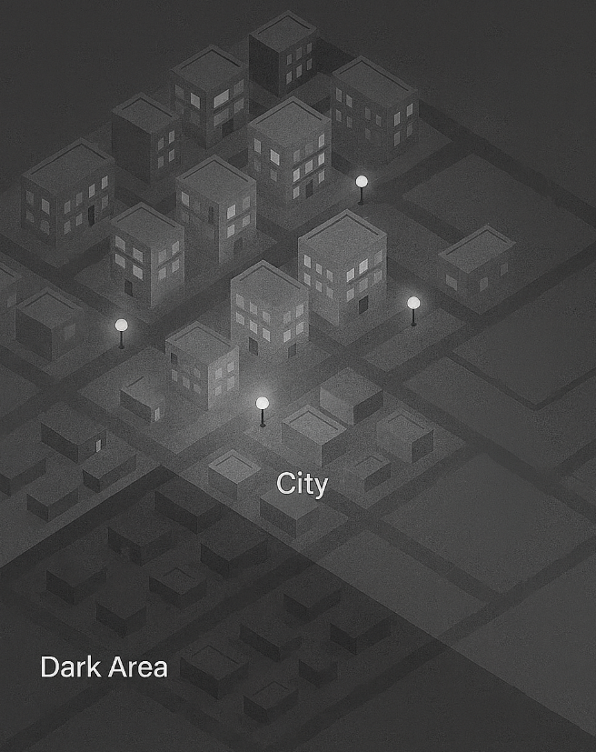
Figure 2: Early Isometric Prototype

Prototype 3: Light and Enemy Relationship
The third prototype explored the interaction between light and enemy behavior. Using rule-based diagrams and annotated sketches, the group tested different conditions under which enemies would appear, move, or disappear. Several variations were discussed, including enemies that were always present versus enemies that existed only in darkness.
This prototype revealed that restricting enemy presence to unlit areas significantly improved clarity and player understanding. The group concluded that enemies should immediately disappear when power is restored, reinforcing light as the primary safety mechanism. This decision directly shaped the final enemy design and behavior rules.
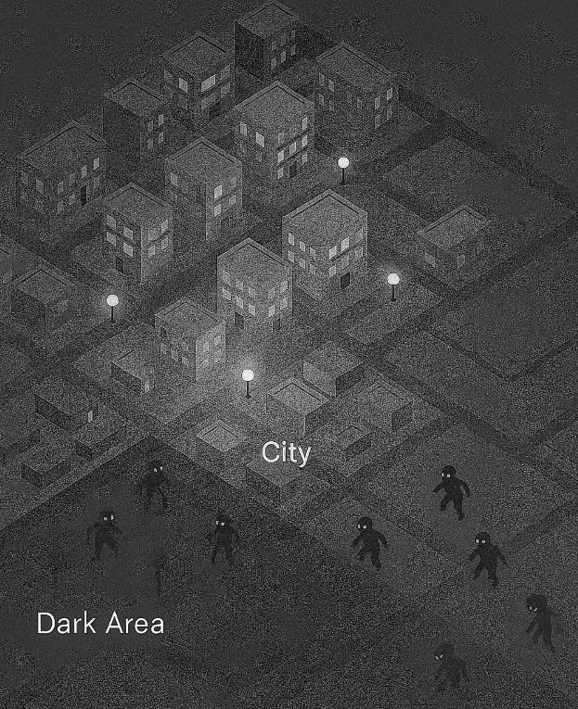
Figure 3: Adding Enemies to Dark Areas

Key Mechanics

Player Movement
The player navigates the city block using keyboard controls (WASD). Movement is continuous and responsive to support fast-paced decision-making and maintain tension throughout the session.

Interaction
Buildings can be interacted with using a single interaction key. Interaction restores power to the building and immediately reactivates lighting in the surrounding area.

Power Decay System
Each building gradually loses power over time. When power reaches zero, the building becomes unlit and unsafe. The rate of power decay increases as the game progresses, providing natural difficulty scaling.

Enemy Behavior
Shadow enemies spawn exclusively in dark areas. These enemies patrol nearby spaces and damage the player on contact. Restoring power to an area causes enemies to disappear instantly, reinforcing the importance of light management.

Core Gameplay Loop
The player repeatedly monitors the city’s power state, navigates efficiently between buildings, restores power, avoids enemies, and attempts to survive until sunrise.

Characters and Settings

Player Character
The player controls a lone city maintenance worker. The character is intentionally understated, allowing the player to focus on gameplay rather than narrative exposition.

Enemies
Shadow enemies are abstract representations of danger and decay. Their minimal design reduces asset complexity while enhancing atmosphere.

Setting
The game takes place within a single city block at night. Streets, buildings, and lighting dynamically change based on the player’s actions, providing immediate visual feedback.

Narrative Context
Narrative is implied rather than explicit. The player’s goal is simply to keep the city functioning until morning, with meaning derived from gameplay outcomes.

Beginning the Game
The game begins immediately without menus or instructional screens. The player is placed in a partially lit city block, allowing exploration and experimentation.
Shortly after the game begins, a nearby building flickers and loses power. A shadow enemy appears, creating a moment of tension. Restoring power removes the enemy, clearly teaching the relationship between light and safety through direct experience.

First 2–5 Minutes
During the first minute, the player learns movement and interaction organically while restoring power to a single building.
Between minutes one and three, multiple buildings begin losing power, requiring prioritization and efficient movement. Enemies appear more frequently in dark areas, increasing pressure.
Between minutes three and five, power decay accelerates, and multiple areas may be unsafe simultaneously. The player must make strategic decisions about which areas to save, fully engaging with the core gameplay loop.

Style
Last Light employs a stylized 2D top-down art style focused on clarity and contrast. Buildings and characters use simple shapes and limited detail, ensuring readability during fast-paced gameplay.
Lighting and shadow are the dominant visual elements. Warm light contrasts with cold darkness to clearly communicate safe and unsafe areas. This approach supports both gameplay clarity and production feasibility.

Audio
Audio design supports atmosphere and gameplay feedback rather than narrative.
Ambient city sounds establish setting, while a looping background track increases in intensity as more areas fall into darkness. Sound effects communicate interaction, danger, and state changes, reducing reliance on textual feedback.

SWOT Analysis

Strengths
A key strength of Last Light is the clarity of its core gameplay mechanic. The relationship between light, safety, and enemy presence is immediately understandable and consistently reinforced through player interaction, which supports the game’s pick-up-and-play design goals. The strong thematic coherence between setting, mechanics, and audiovisual presentation helps create a focused and immersive experience without relying on complex systems or narrative exposition.
Another significant strength is the project’s carefully managed scope. By limiting the game to a single environment with escalating phases rather than multiple levels, the design minimizes asset requirements and reduces development risk. This approach allows the team to prioritize polish, balancing, and playtesting, increasing the likelihood of delivering a stable and complete final product within the available timeframe.

Weaknesses
One potential weakness of the design is the limited variety inherent in a short, single-session experience. Because the game relies on a small number of mechanics, there is a risk that gameplay could feel repetitive if pacing and difficulty scaling are not carefully tuned. Maintaining player engagement across the full 5–10 minute duration therefore depends heavily on effective escalation and feedback.
Additionally, the game’s reliance on lighting as the primary visual communication tool introduces a dependency on clarity and readability. Poor lighting contrast, unclear visual cues, or inconsistent feedback could negatively affect player understanding and enjoyment. This places additional importance on visual testing across different screen sizes and environments.

Opportunities
The minimalist structure of Last Light presents strong opportunities for refinement and polish. Because the core mechanics are simple and parameter-driven, difficulty can be adjusted through timing, enemy frequency, and power decay rates without introducing new systems. This allows for meaningful iteration based on playtesting feedback.
The game also provides opportunities to explore environmental storytelling within a constrained space. Subtle visual and audio changes over time can enhance atmosphere and tension without increasing mechanical complexity. This supports the project’s goal of delivering an engaging experience within a short playtime.

Threats
A primary threat to the project is the challenge of balancing enemy behavior to ensure the game remains challenging without becoming frustrating. If enemies are too aggressive, players may feel overwhelmed; if too passive, the sense of danger may be lost. Achieving the correct balance will require iterative testing and adjustment.
Another potential threat is technical performance related to lighting and visual effects, particularly if dynamic lighting is overused. Performance issues could impact gameplay smoothness and readability. To mitigate this risk, the team will prioritize simple lighting techniques and optimize effects early in development rather than adding them late in the production cycle.

Production Schedule (12 Weeks)
Week | Phase | Juan (Lead/Code) | Dianshi (Systems) | Agata (Design/UI) | Ionut (Assets)
1 | Setup | Set up GitHub repository. Implement player movement. | Work on the "Power Decay" timer logic. | Sketch the city layout. Set up the Unity Scene. | Search for free sprite packs (player/city/  enemy) and sound effects (clicks, ambience hums).
2 | Core | Work on interaction mechanics (turning lights on/off). | Work on the "Game State" (active vs. game over). | Build the basic level. Implement camera logic. | Configure lighting settings (shadows/  colors).
3 | Enemies | Work on player health and damage logic. | Work on enemy spawning logic (where they appear). | Design HUD assets. Implement the UI manager (Health bars). | Import sprites & set up animations.
4 | Review | Feedback and group review. | Feedback and group review. | Feedback and group review. | Feedback and group review.
5 | Logic | Connect UI bars to player health logic. | Work on basic enemy movement (chasing player). | Place buildings into the final scene. | Implement audio manager (play sounds on events).
6 | Buffer | Downtime / Catch-up | Downtime / Catch-up | Downtime / Catch-up | Downtime / Catch-up
7 | Flow | Work on "Sunrise" (win) and "Death" (lose) events. | Implement difficulty scaling (decay speeds up). | Create the title, pause and credit screens. | Add final lighting effects (glow/atmosphere).
8 | Polish | Adjust movement speed and feel. | Adjust enemy speed and aggression. | Add details to the city (props/  decorations). | Adjust sound volumes (balance music/SFX).
9 | Testing | Group playtesting | Group playtesting | Group playtesting | Group playtesting
10 | Fixes | Fix movement bugs found in testing. | Adjust difficulty based on testing. | Fix UI bugs found in testing. | Add final sound effects (clicks/buttons).
11 | Final | Final code cleanup | Final check of all scripts. | Final check of scene/level. | Check asset licenses & create credits list.
12 | Submit | Submission | Submission | Submission | Submission

Buffer time is included to accommodate unforeseen delays.

List of All Assets

Visual Assets
Asset | Priority | Estimated Time
Player sprite | Essential | Low
Building sprites | Essential | Medium
Shadow enemy sprites | Essential | Medium
Lighting effects | Essential | Medium
UI elements | Essential | Low

Audio Assets
Asset | Priority | Estimated Time
Background music | Very Important | Low
Interaction sounds | Essential | Low
Enemy sounds | Nice to have | Low

Systems to Program
System | Priority | Estimated Time
Player movement | Essential | Medium
Interaction system | Essential | Medium
Power decay | Essential | Medium
Enemy AI | Essential | Medium
Game state and timer | Essential | Medium

Conclusion
This design document outlines a focused, achievable game concept aligned with the project constraints and assessment criteria. By prioritizing clarity, iteration, and scope control, Last Light provides a strong foundation for successful development during the final project phase.

